Ventilator 2020

User Guide

V 1.0

5 April 2020

Model: Ventilator 2020

Manufacturer: Name and address of the organisation releasing the device into the market under their name

**Table of Contents**

1 Introduction 3

1.1 Intended use 3

1.2 Device 3

1.3 Combination devices 4

1.4 User responsibility 5

1.5 Warnings 6

1.6 Clinical warnings 6

2 User interface 7

2.1 Control 8

2.2 Setting up the ventilator breathing circuit 8

2.3 Monitoring 9

3 Display messages and alarms 9

3.1 Messages 9

3.2 Alarm messages 10

3.3 Alarm visual and audible indicators 14

3.4 Conditions that temporarily suspends the alarms 14

4 Functional testing 14

5 Battery 14

6 Extended storage 15

7 Cleaning and disinfection 15

7.1 Cleaning – recommended method 15

7.2 Disinfection – recommended method 16

8 Gas supplies 16

9 Operating environment 16

10 Power requirements 16

11 Dimensions 16

12 Connectors 17

13 Classification of Medical Electrical System (via power supply unit) 17

14 Environmental storage conditions 17

15 Product life cycle 17

16 Maintenance and calibration 17

17 EMC compliance 18

18 Preparation of a new ventilator 19

19 Pneumatic diagram 19

20 Serial data port 21

# Introduction

## Intended use

The ventilator is intended for providing mass intensive respiratory care, in facilities that might be lacking in full hospital infrastructure and clinical experiences – such as under pandemic emergency conditions.

The device is intended for use with adult and young adult patients from 50kg and upwards.

|  |
| --- |
| * Ventilator requires a pre-blended air-oxygen mixture. * Ventilation efficiency should be monitored using a TcCO2 or EtCO2 device, to measure CO2 elimination; and a SpO2 device, to measure blood oxygen saturation. * Other vital signs monitoring is also recommended. |

## Device

The ventilator is designed for a simplified clinical protocol that demands minimal training and re-training. It is further designed to be mass-producible and requiring minimal maintenance. The gas cycling operation is designed to minimise oxygen consumption.

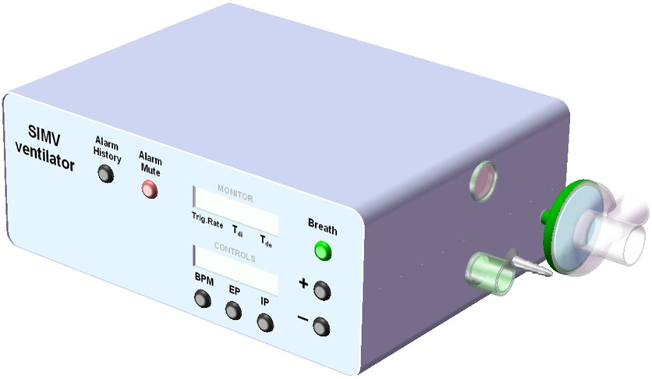

The ventilator uses conventional Pressure Controlled SIMV (Synchronised Intermittent Mandatory Ventilation) mode of ventilation only. It interfaces with intubated, unconscious and semi-conscious, patients; and it interfaces with pressure ventilation masks on conscious patients. There is no need to select and switch between alternative modes or interfaces.

For purpose of simplicity, the I:E ratio (Inspiratory-Expiratory) is fixed 1:2. Inspiration flow rate fixed 60L/min, which produces an IP rise time of about 0.45s into a 600mL lung.

SIMV behaves as PSV (Pressure Support Ventilation) when the patient makes full efforts, and it behaves as CMV (Continuous Mandatory Ventilation) if the patient does not make any efforts. When used with a mask on a conscious, spontaneously breathing patient, the SIMV behaves as nPSV or Synchronised BiPAP (by setting IP low). Switching the IP cycle off (or setting it equal to PEEP) makes SIMV behaves as CPAP (whether the patient is intubated or has a mask interface).

The device is not intended to be marketed as a commercial medical device. The device conforms to medical device requirements for basic safety and essential performance. There is not, yet, any basis for proving the clinical efficacy of the device.

The ventilator is designed to operate in combination with an external power supply, a breathing circuit and a respiratory gas humidifier (HME or water chamber).

The ventilator features two one-way valves, which enables the spontaneously breathing patient to take in fresh ambient air in case of power and gas supply failures.

## Combination devices

The ventilator receives electrical power from an external power supply. Under the definitions for medical electrical equipment (standard IEC 60601-1), the ventilators forms part of a mains power connected Medical Electrical System (MES). The ventilator itself is not a mains connected Medical Electrical Equipment (MEE). The power supply unit must therefore conform to national standards for MEE (e.g. it should have CE or national equivalent mark). The power cord must be attached to the ventilator, using a P-clip, to prevent accidental disconnection.

The 22mm breathing circuit should also meet medical device standards. The simplest configuration of breathing circuit is preferred. The circuit must as minimum contain an HME (Heat Moisture Exchange) device. The breathing circuit must have a maximum compliance of 5ml/mbar (or 5ml/cmH2O) and a maximum resistance of 1mbar (or 1 cmH2O) at 30L/min flow rate. These values are met by most available 22mm circuits in the market.

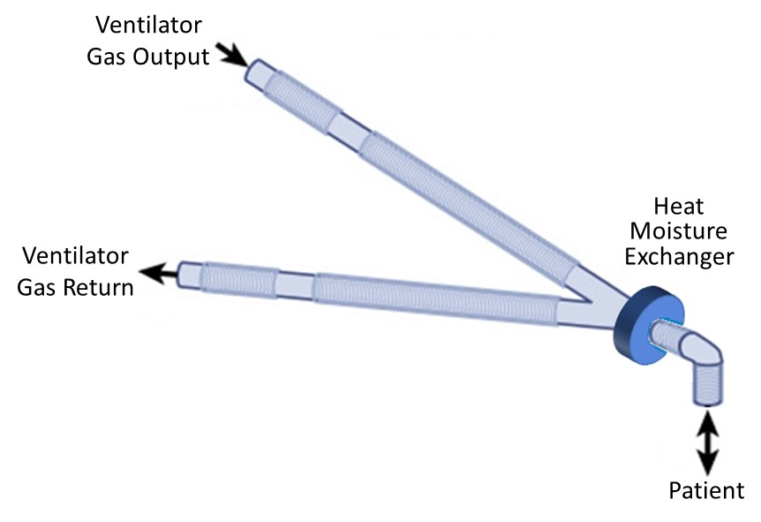

The HME may be replaced by introducing a water bath or ultrasonic humidifier on the ‘Gas Output’ side of the breathing circuit. This should normally be matched by a water trap on the ‘Gas Return’ side of the circuit, to collect the moisture that otherwise collects inside the tubes.

In the event of total power or gas supply failure, the ventilator incorporates a pair of low resistance directional valves to enable spontaneous breathing, without rebreathing. The resistance to breathing depends on the breathing circuit and any attachments (e.g. bacteria filter).

The ventilator may use a combination ultrasonic nebulizer, which does not add an extra gas flow to the breathing circuit. DO NOT use gas driven nebulizers.

Exhalation exhaust port is standard 22mm connector, enabling bacterial filter or (via adapter) gas scavenging to reduce the risk of cross-contamination

At system level, the ventilator forms part of a scalable multi-devices arrangement. The ventilators receive pre-blended gas, from one of selectable supply lines. This arrangement significantly simplifies the ventilator design. The example here shows 2 parallel gas lines (but this could be 3 or 4), supplying pre-blended 25% and 40% FiO2 (finally inspired oxygen concentration) respectively. The FiO2 settings can be changed to whatever clinicians prescribe for the particular group of ventilators.

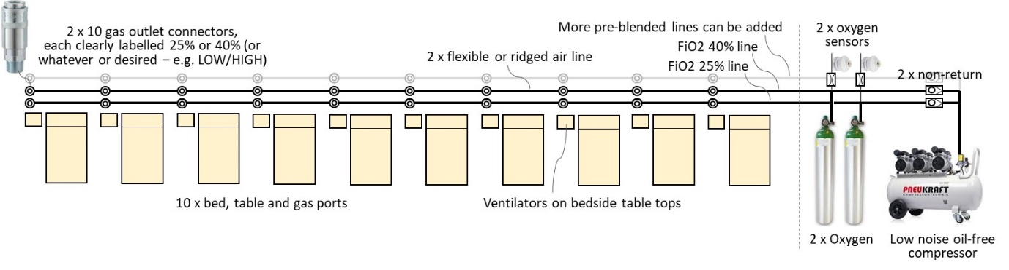

## User responsibility

The ventilator and the accessories for it are designed for use in accordance with the displayed labels and supplied instructions. User must be suitably, clinically trained and authorised by their clinical management to operate the ventilator. Oxygen is a drug and should be prescribed as such.

The equipment and gas supply hoses must be periodically checked, maintained and components repaired and replaced, when necessary, for the equipment to operate safely and reliably.

Parts that have failed, in whole or in part, or exhibit excessive wear, or are contaminated, or are otherwise at the end of their useful life, should not be used and must be replaced immediately with approved parts.

The use of oxygen requires special precaution to avoid fire hazards. Keep all sources of ignition away when oxygen is in use. Do not use oil or grease on high-pressure oxygen fittings.



## Warnings

### DO NOT use a gas flow driven Nebulizer during ventilation.

### A hazard can exist when equipment with similarly sounding audible alarms are used in the same area. Observe the alarm lights as well as listening.

### An alternative form of ventilation should be on standby.

### Use a power supply unit that is conformity assessed to national standards for Medical Electrical Equipment (e.g. has a CE or national equivalent mark).

### The ventilator must be connected to a suitably rated and grounded electrical power source, via the power supply unit.

### The ventilator IS NOT compatible with MRI scanner control zones and other equipment radiating high electro-magnetic power.

### In case of low confidence in the contamination status of the supply gas, then use a particle and appropriate filer on the ‘Gas Output’ port.

### If the battery is allowed to completely discharge, then it should be recharged a soon as possible. This is to avoid damaging the battery by allowing it to remain in a deep discharged state.

### If the ventilator is not going to be used for a period in excess of 40 days then disconnect the battery from the power supply.

### Failure to comply with the recommended service and maintenance programs could lead to injury of the patient, operator or damage to the ventilator.



## Clinical warnings

### Use conventional Pressure Control SIMV ventilation only.

### Patient breath triggering is limited to one trigger sensitivity with strong spontaneous efforts.

### There are inherent risks in the use of mechanical ventilation. Use appropriate monitoring of patient status and outcomes.

### Failure to take corrective action when the alarms are activated could result in serious injury to a patient.

# User interface

User interface is divided into a ‘Monitor’ and a ‘Control’ section.

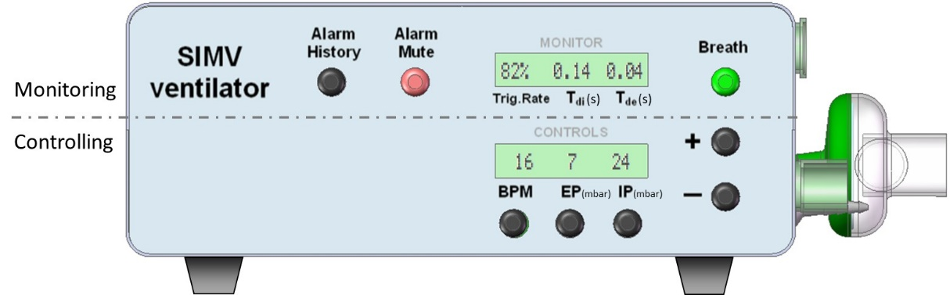

The ventilator monitors and displays 3 values:

* Trigger Rate: The percentage of delivered breaths instigated by spontaneous patient effort. Its trend indicates patient progress or deterioration.
* Tdi: IP rise time, indicates lung compliance, but also if gas supply becomes restricted.
* Tde: Expiration wave decay time, indicates if the bacterial filter or patient circuit is soiled (excessively resistive) and need replacing. Where a small resistance is added to the exhaust (e.g. bacteria filter) the Tde can also help indicate lung obstruction (fluids, secretions).

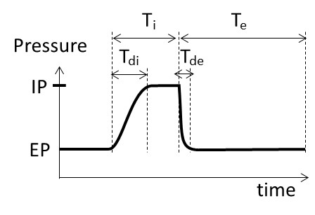

The ‘Alarm’ button lights up or flashes when an alarm condition exists. Alarm messages appear in the monitor display (temporarily flashing the values).

The ‘Breath’ button lights up during the IP phase, to indicate ventilator cycling.

The ventilator has 4 controls:

* BPM (Breath Per Minute): 10 to 30, in 1 steps.
* EP (Expiration Pressure, same as PEEP): 4 to 25mbar, in 1 steps.
* IP – Inspiration Pressure (same as PIP): 4 to 35mbar, in 1 steps.
* Manual breath: Active while ‘Breath’ button is pressed.

Note: 1 mbar = 1.02 cmH2O and the 2 units can be considered practically equal.

## Control

To power up the ventilator, press on/off switch on the rear. Observe the power-up self-test correctly displays LEDs and the display digits.

To power down the ventilator, press on/off switch on the rear. The monitor display will display a message saying ‘Power OFF?’ for 5 seconds. During this short period, press and hold any of the buttons for 2 seconds. If the 5-second message is missed, then simply flick the on/off switch again, to restart the 5-second message.

If none of the buttons are held for 2 seconds, or just pressed momentarily, the message will disappear and the ventilator will continue to operate under battery power. This enables moving the patient or intra-hospital transport.

Adjusting a control parament:

1. Press the button underneath the parameter to be adjusted.
2. Observe that the parameters value starts flashing. It will time out after 5 seconds of inactivity.
3. Adjust the flashing parameter value using the +/- buttons.
4. Press parameter control button again to confirm the new setting.

The ‘Breath’ button delivers a manual breath. This is used to re-recruit the lung following a procedure that temporarily disconnected the patient from the ventilator, such as during suctioning or while changing the FiO2 level.

The ‘Alarm Mute’ button will suspend the alarm sounder for 120 seconds. It will also un-latch any existing alarm (see section 3.2). Alarms will trigger or re-trigger while the sound is muted. Observe the message display.

The ‘Alarm History’ cycles through the last 10 alarm messages.

## Setting up the ventilator breathing circuit

Before switching on the ventilator (to avoid unnecessary alarming):

* Push the exhalation valve onto the ventilator’s spigot labelled ‘Gas Return’.
* Push the exhalation valve’s pressure tube to the ventilator’s spigot labelled ‘Patient Pressure’
* Connect the circuit expiratory limb to the exhalation valve’s 22mm Female on the ventilator’s ‘Gas Return’ port.
* Connect the circuit inspiratory limb to the ventilator’s 22mm Male ‘Gas Output’ port.
* Connect the HME (or alternative humidification).
* Switch on the ventilator and verify for leaks/poor connections.

The circuit may be set up in advanced and verified using a test lung; and then capped off to protect hygiene.

## Monitoring

Periodically observe and record the 3 monitored values. Look for trends that could indicate a change in patient condition, lung function or ventilator system performance.

|  |
| --- |
| * TcCO2 or EtCO2, and SpO2, which indicates the blood gasses, should also be recorded (EtCO2 tends to represent the blood CO2). * It is recommended to record the trending of other vital signs. * Any changes in the trends should be reviewed or investigated by a suitably qualified clinician, with view to prescribe adjustments to the ventilator settings or associated therapy. |

A decreasing Trigger Rate could indicate a deterioration in patient conditions.

A decreasing Tdi could indicate declining lung compliance and onset of ARDS (Acute Respiratory Distress Syndrome). The clinician might want to review (with blood gas measures) and consider whether to increase IP to achieve sufficient Tidal Volume, or increase BPM to achieve sufficient Minute Volume.

An increasing Tdi could indicate improving lung compliance. The clinician might want to review (with blood gas measures) and consider if IP can be reduced, to maintain a steady Tidal Volume and prevent over-distending the lung.

An increasing Tdi, if it happens across all patients connected to the same gas supply, could also indicate that gas supplies are ‘starved’.

An increasing Tde could indicate increasing resistance in the breathing circuit exhalation path, as result of tubing or bacterial filer being soiled.

# Display messages and alarms

## Messages

The user interface messages displayed on the two 16 character wide LCDs.

|  |  |  |
| --- | --- | --- |
| User message | Description | Action |
| Monitor and control parameter values | Normal operation, within expected tolerances. | None |
| Audio Paused  (message alternates with underlying original message) | Indicates that user has activated the alarm audio cancel or alarm ‘pre-mute’. | Pauses alarm audio for 120 seconds, or until button or is pressed again.  Un-latches any latched alarm conditions. |
| Confirm Change | User has commenced adjustment of a BPM, EP or IP parameter. | Adjustment is NOT accepted until parameter button is pressed again.  Times out and reverts to prior values after 5 sec of inaction. |
| Ventilator v1.0 | Version display during power-on-self-test. | Clears itself on completion of the power-on-self-test. |
| Ready... | Indicates that power-on-self-test has completed. | Clears itself after 2 sec |
| <no message> | Indicates that a particular history log location does not have any stored event (i.e. alarm has not occurred) | None |
| Power OFF??? | The user has moved the rear mechanical power switch to OFF position. | Press and hold any button on the facia for 2 sec. To power down.  OR, do nothing, to continue to operate in battery power mode. |

## Alarm messages

Alarm messages ranked in order of priority. The current message of highest priority ranking is stored in the history log. Simultaneous lower ranking messages are often the consequence of a higher priority, and they are not stored in the history log. The term ‘alarm’, when used in the Action column, means sounding and displaying a conforming audio-visual alarm.

A latching alarm is an alarm message that once generated will continue to display both the audible and visual elements, even though the original alarm condition has cleared. The user must acknowledge and un-latch the alarm, by pressing the ‘Alarm Mute’ button.

A non-latching alarm is an alarm message that will display both the audible and visual elements only during the alarm condition. If the alarm condition clears the audible and visual elements self-cancel.

The alarm messages below are ranked in order of priority. The current message of highest priority ranking is stored in the history log. Simultaneous lower ranking messages are often the consequence of a higher priority, and they are not stored in the history log (they will of course re-appear once the higher priority is resolved, if they still exist by then). The term ‘alarm’, when used in the Action column, means sounding and displaying a conforming audio-visual alarm.

| Alarm message | Description | Action |
| --- | --- | --- |
| (blank display)  Simultaneous ‘Battery fail’ and ‘Mains disconnect’ | Total power loss. Battery has emptied (below 10v), while in battery operating mode.  Priority: HIGH  Group: TECHNICAL  Type: N/A  Note: This follows a prolonged ‘battery low’ alarm (see below) | Ventilation stops (unsafe). Alarm sounder will continue for 10 seconds or until power is manually switched off. |
| ‘Monitor Fail’  (shown in bottom Control LCD) | Hardware and/or software failure in Monitor. Cannot have confidence in ventilator operation.  Priority: HIGH  Group: TECHNICAL  Type: LATCHING | Cannot be disabled. Remove ventilator from service. |
| ‘Control Fail’  (shown in bottom Control LCD) | Hardware and/or software failure in Controller. Cannot have confidence in ventilator operation.  Priority: HIGH  Group: TECHNICAL  Type: LATCHING | Cannot be disabled. Remove ventilator from service. |
| ‘Gas Failure’ | Ventilator unable to reach any pressure. Gas supply not available.  Priority: HIGH  Group: TECHNICAL  Type: LATCHING | Check supply.  If supply is good, then remove ventilator from service. |
| ‘High pressure’ | Patient circuit pressure exceeded 40mbar. Ventilator shut down its gas supply, but will make attempt to restart after 1 second (it could be a patient cough).  Priority: LOW (for one off)  Group: TECHNICAL  Type: NON-LATCHING  If the pressure exceeds 40mbar for a second time within 3 seconds (indicating a technical failure), then the gas will remain shut off.  Priority: HIGH  Group: TECHNICAL  Type: LATCHING | The first alarm is non-latching. It is recorded in the history log.  Second alarm is latching and gas supply will remain shut off. Operator must press ‘Alarm Mute’ button to restart ventilation.  Examine patient circuit and exhalation valve for obstruction. Else, remove ventilator from service. |
| ‘Circuit Failure’ | Ventilators cycles normally, but circuit pressure is not achieved. Assume accidental disconnection. Or, could be a manual intervention for a temporary normal medical procedure (e.g. suctioning).  Priority: HIGH  Group: TECHNICAL  Type: NON-LATCHING | Examine patient circuit and exhalation valve for correct connections.  If failure persists, remove ventilator from service. |
| ‘Battery Low’ | Device is operating on battery power, and battery has <10% capacity remaining (approx. 10 to 20 minutes)  Priority: MEDIUM  Group: TECHNICAL  Type: NON-LATCHING  Is repeated as HIGH priority alarm 1 minute before total shutdown.  Priority: HIGH  Group: TECHNICAL  Type: NON-LATCHING | Connect power supply.  Check fuse in power supply. Replace if necessary.  Alarm clears automatically when battery re-charges. |
| ‘EP Below Set’ | EP is more than 2mbar below the set value, for more than 3 breaths.  Priority: MEDIUM  Group: TECHNICAL  Type: NON-LATCHING | Examine patient circuit and exhalation valve for correct connections.  If failure persists, remove ventilator from service. |
| ‘EP Above Set’ | EP is more than the 2mbar above the set value, for more than 3 breaths.  Priority: MEDIUM  Group: TECHNICAL  Type: NON-LATCHING | Examine patient circuit and exhalation valve for correct connections.  If failure persists, remove ventilator from service. |
| ‘IP Below Set’ | IP is more than 3mbar below the set value, for more than 3 breaths.  Priority: MEDIUM  Group: TECHNICAL  Type: NON-LATCHING | Examine patient circuit and exhalation valve for correct connections.  If failure persists, remove ventilator from service. |
| ‘IP Above Set’ | IP is more than the 2mbar above the set value, for more than 3 breaths.  Priority: MEDIUM  Group: TECHNICAL  Type: NON-LATCHING | Examine patient circuit and exhalation valve for correct connections.  If failure persists, remove ventilator from service. |
| ‘Tdi Too Long’ | Tdi exceeds 0.7s. Possible excessive circuit leak or a supply gas flow issue.  Priority: MEDIUM  Group: TECHNICAL  Type: NON-LATCHING | Examine patient circuit and exhalation valve for correct connections.  If failure persists, remove ventilator from service. |
| ‘Tde Too Long’ | Tde exceeds 0.7s. Possible resistive obstruction in expiratory tube or exhalation valve, or soiled bacteria filer.  Priority: MEDIUM  Group: TECHNICAL  Type: NON-LATCHING | Examine patient circuit and exhalation valve for correct connections. |
| ‘No Power Supply’ | Power supply is interrupted.  Priority: LOW  Group: TECHNICAL  Type: NON-LATCHING  Does not repeat once acknowledged. | Continue on battery power.  Connect power supply. Replace if necessary.  Check fuse in power supply. Replace if necessary. |

## Alarm visual and audible indicators

The unit produces three alarm tones, corresponding to priorities, High, Medium and Low.

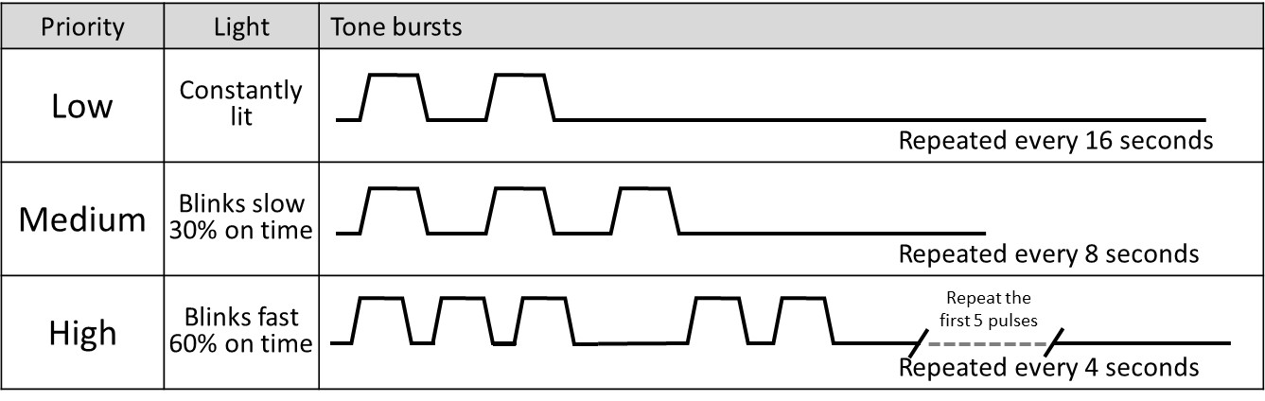

The pulsed tones are generated when the unit encounters an alarm condition. All the generated tone alarms are accompanied by visual alarm indication.

## Conditions that temporarily suspends the alarms

| Condition | Action |
| --- | --- |
| Power-up | On power up, the ‘Gas Failure’ and all Medium priority alarms are suspended for 1 min that follows the self-test, to allow the system to settle. |
| Parameter change | On changing a EP and IP settings, the EP and IP related alarms are suspended for 10 seconds, to allow the system to respond to the change. |

# Functional testing

The ventilator can be tested with a test lung attached. It should be noted that a test lung does not necessarily have the resistance and compliance of a natural lung. Breath detection can be simulated by pulling on the test lung, to expand its volume.

# Battery

The ventilator contains 1 sealed lead acid battery that can operate the unit for at least 45 minutes in the event of a mains power fail situation. The 45 minutes period is for a battery that is in a good condition.

If the ventilator has been used on battery power and it has been allowed to fully discharge the battery, then the battery can be described as being in a deep discharged state. If the unit is stored or placed out of service without recharging the battery, the deep discharged state can severely reduce the battery life. The damage is irreversible and the battery must be replaced.

# Extended storage

If the ventilator is to be stored away for a period greater than 30 days and is not possible to charge the battery during this time, then the following procedure is recommended to prevent deep discharge damage to the battery:

* Remove the ventilator’s top cover.
* Disconnect the negative battery terminal and move it away from the battery.
* Tie a label to the ventilator to say the battery is disconnected.

# Cleaning and disinfection

The pre-assembled patient circuit is intended for single-use. Patient contaminants do not reach any parts of the ventilator, other than the single-use patient circuit. Cleaning and disinfection is generally not required between patients.

All cleaning, disinfection and sterilizing of the ventilator should be carried out under the direction of the appropriate hospital authority procedures and standards.

Before cleaning or disinfecting the exterior of ventilator the following tasks should be performed:

* The power supply mains cable should be disconnected from the socket.
* Remove the patient circuit and bacterial filters. Discard any single-use items as per appropriate hospital authority guidelines.
* Disconnect the gas supply.

## Cleaning – recommended method

For cleaning use 3 clean, disposable, absorbent, non-shedding cloths.

1. Wipe clean with the first cloth using a hand warm water or a mild general purpose detergent solution. Do not overload the cloth with liquid.
2. Remove the first water and/or detergent solution with the second cloth using water only. Do not overload the cloth with liquid.
3. Wipe dry with the remaining cloth. Care should be taken to ensure that the driver gas ports are not blocked by any debris.



DO NOT insert any object in to the gas ports. This action may result in damage to the port. If the user believes there is a foreign object in a gas port, please refer the device to qualified service personnel for inspection and repair.

DO NOT allow moisture to enter the electronic module or its electrical sockets.

DO NOT steam autoclave any part of the ventilator or otherwise subject it to temperatures above 60°C.

DO NOT immerse any part of the ventilator into any liquid.

DO NOT use solvent-based cleaning agents on paint and label surfaces.

DO NOT use any abrasive cleaners on display and label surfaces.

## Disinfection – recommended method

Alcohols such as 70% isopropanol have some activity against bacteria and viruses. They should only be used after all visible surface dirt has been removed from the area to be disinfected.

For disinfection use two clean, disposable, absorbent, non-shedding cloths. Wipe clean with the first cloth using Alcohol (70% isopropanol). Wipe dry with the remaining cloth.



Disinfectants containing compounds similar to PHENOL or ALKYLAMINES (Glucorrotamine) are unsuitable.

# Gas supplies

High pressure gas supply is required at 2.5 bar to 5 bar.

Air must be medical grade to ISO8573.1 Class 1.4.1 (minimum level of filtration).

Nominal inlet gas flow is 60 L/min. Peak inlet gas flow is less than 80 L/min.

# Operating environment

Temp: 10-40 ºC.

Humidity: 0-90% (non-condensing).

# Power requirements

Voltage: 13.5v

Power: 60 VA

Battery: 12V 2.1AH sealed lead acid.

Battery back-up: More than 45 minutes.

Battery charging: Full charge - Up to 8 hours

Fuse (Battery): 1 off T2.0A 250V

# Dimensions

Size of ventilator: 280 mm W x 210 mm D x 106 mm H

Weight, without patient circuit: 2.5 kg

# Connectors

Gas Output port: 22mm Male conical connector to ISO5356-1

Gas Return port (on exhalation valve): 22mm Male conical connector to ISO5356-1

Patient Pressure port (on ventilator): Non-conical barbed spigot

# Classification of Medical Electrical System (via power supply unit)

Type of protection against electric shock: Class I.

Degree of protection against electric shock: Type B.

IPX rating IP44

Unit must be earthed.

# Environmental storage conditions

When packed for transport or storage;

Ambient Temperature: -40°C to +70°C

Relative Humidity: 10% to 90% non-condensing

Atmospheric Pressure: 500 hPa to 1060 hPa

# Product life cycle

The ventilator has a product life of 8 years from the date of manufacture. This excludes the main battery, which has an approximate 4-year life.

Solenoid valves should be replaced with new or overhauled valves every 10,000 hours, or every 2 years of regular use.

Apart from the battery, the ventilator and accessories do not contain any special hazardous components. No special precautions are required for their disposal. The device should be disposed of in accordance to the local WEEE (Waste Electrical and Electronic Equipment) guidelines.

At the end of its useful life this battery should be disposed of in accordance with local authority guidelines.

# Maintenance and calibration

Functionally test and calibrate the ventilator at least every 3 months, or if there is reason to believe performance could have drifted:

* Attach a calibrated flow meter to the ‘Gas Output’ port. The flow meter should vent into ambient (no breathing circuit attached). Power up the ventilator (mute any alarming). Press and hold the ‘Breath’ button. Adjust the pressure regulator (PR), until the flow is 60L/min. Lock the pressure regulator.
* In a set up with a test lung and connecting a calibrated pressure measurement device, verify that the set ventilator pressure corresponds to actual measured pressure.
* In a set up with a test lung, manipulate the test system to cause the various alarm conditions described in section 3.2 above. Confirm the ventilator triggers them correctly.

Complete overhaul, including replacing worn labels, solenoid valves and battery (if required) should be performed every 2 years, or earlier if the ventilator is damaged.

# EMC compliance

The ventilator’s electromagnetic compatibility was summarily assessed to meet the requirements of the following relevant standards:

EN60601-1-2

EN61000-3-2

EN61000-3-3

|  |  |  |
| --- | --- | --- |
| Guidance and manufacturer's declaration - electromagnetic emissions | | |
| The ventilator is intended for use in the electromagnetic environment specified below. The customer or the user of the Xenon Blender should assure that it is used in such an environment. | | |
| Emissions test | Compliance | Electromagnetic environment- guidance |
| RF emissions  CISPR 11 | Group 1 | The ventilator uses RF energy only for its internal function. Therefore, its RF emissions are very low and are not likely to cause any interference in nearby electronic equipment. |
| RF emissions  CISPR 11 | Class B | The ventilator is suitable for use in all establishments and may be used in domestic establishments and those directly connected to the public low-voltage power supply network that supplies buildings used for domestic purposes, provided the following mandatory warning is paid attention to:    Warning: This equipment/system is intended for use by healthcare professionals only. This equipment/ system may cause radio interference or may disrupt the operation of nearby equipment. It may be necessary to take mitigation measures, such as re-orienting or relocating the ventilator or shielding the location. |
| Harmonic emissions  IEC 61000-3-2 _ | Class A |
| Voltage fluctuations/  flicker emissions  IEC 61000-3-3 | Complies |

# Preparation of a new ventilator

Remove all transit packaging. Inspect the gas ports and proximal airway port for any packing material. Retain packaging for future storage or transportation use.

Remove the protective film.

Examine the ventilator for visual damage.

Allow the unit to acclimatize – i.e if the device has been stored in a cold or humid environment whilst in transit/storage, then wait at least 4 hours.

# Pneumatic diagram

The Monitor and Controller operate independently, in parallel, observing each other (watchdogs). This assures the detection and alarming on any single failure mode. Both the controller and the monitor are capable of detecting an excess pressure (>40 mbar) and each can shut down the supply gas. This duality safeguards that compressed gas does not reach the patient circuit. All valves are NC (normally closed) types and will default to shutting off gas supply in case of total (battery) power failure.

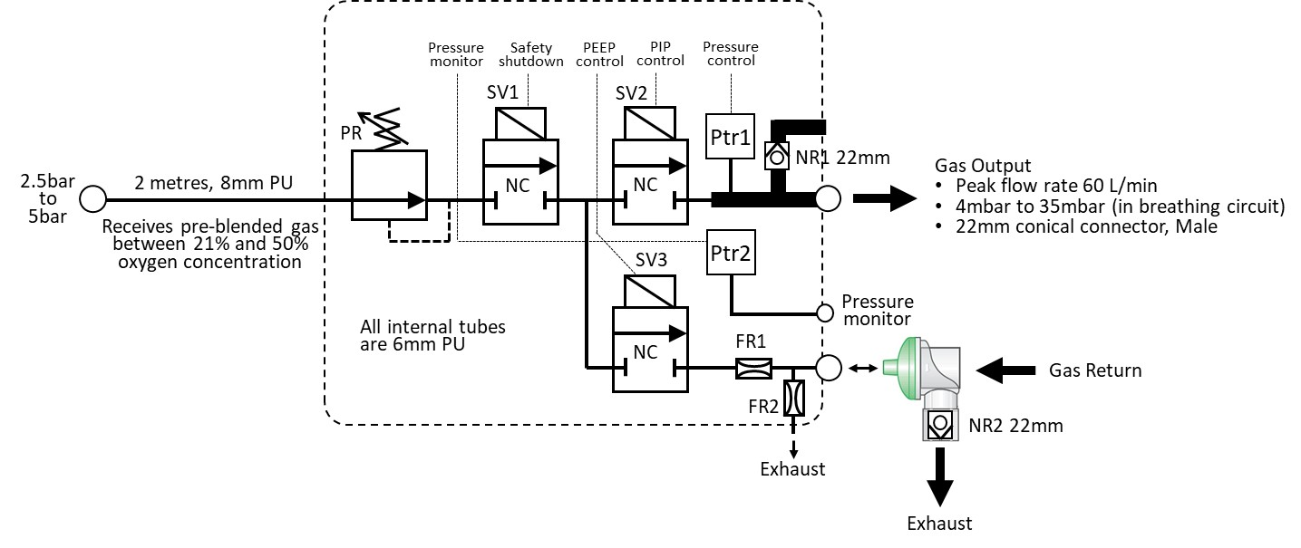

The Controller operates its own user interface, for adjusting the parameters (BPM, EP and IP). The Controller reports its 3 parameters values every 50mS to the Monitor. The Controller also reports when a valid change is made via the user interface. If the Monitor does not acknowledge receipt, then the Controller will instigate an alarm.

On shut-down, the patient can breathe ambient air through the 2 directional NR valves.

Overview flow diagram of ventilation cycle.

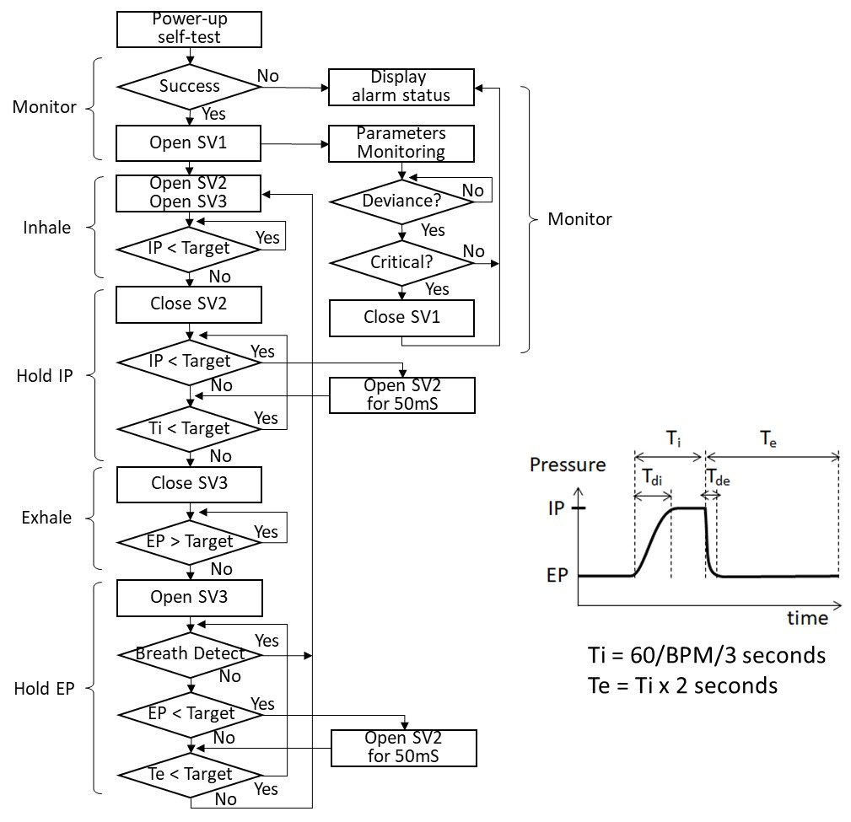

Note: When SV3 opens, then the Exhalation Valve closes. The short 50mS opening of SV2 tops up the IP or EP during the ‘hold’ phases, to compensate for any leak.

Trig.Rate = number of triggered breaths divided by total delivered breaths, over the last 50 breaths. The value is in effect averaged over the last 3 minutes approximately.

The Tdi measure the time from starting the inspiration cycle, until the IP plateau is reached. The displayed value is averaged for the last 20 breaths, to display a stable value. This averaging will still detect a natural, gradual drift.

The Tde measure the time from starting the expiration cycle, until the EP plateau is reached. The displayed value is averaged for the last 20 breaths, to display a stable value. This averaging will still detect a natural, gradual drift.

The breath detection looks for a real-time small pressure drop on the EP plateau pressure, which indicates the patient’s own inhalation work.

# Serial data port

The data port is situated on the main PCB, inside the control unit enclosure. This feature is available for upgrading the ventilator software. The control unit enclosure should not be opened and the data port must not be connected to during clinical use.